Here are two rectangles with a point (C) inside. The point is joined to two adjacent corners (A and B). The angles at A, B and C are shown.

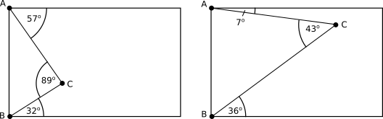

Draw some of your own examples and measure the angles. What do you notice?

Alison made a conjecture: "The angle at A and the angle at B add together to give the angle at C."
Do your examples support Alison's conjecture?
Can you prove Alison's conjecture?
Can you prove it in more than one way?
What happens if you start with a parallelogram?
Or a trapezium?
What if the point goes outside the rectangle?

